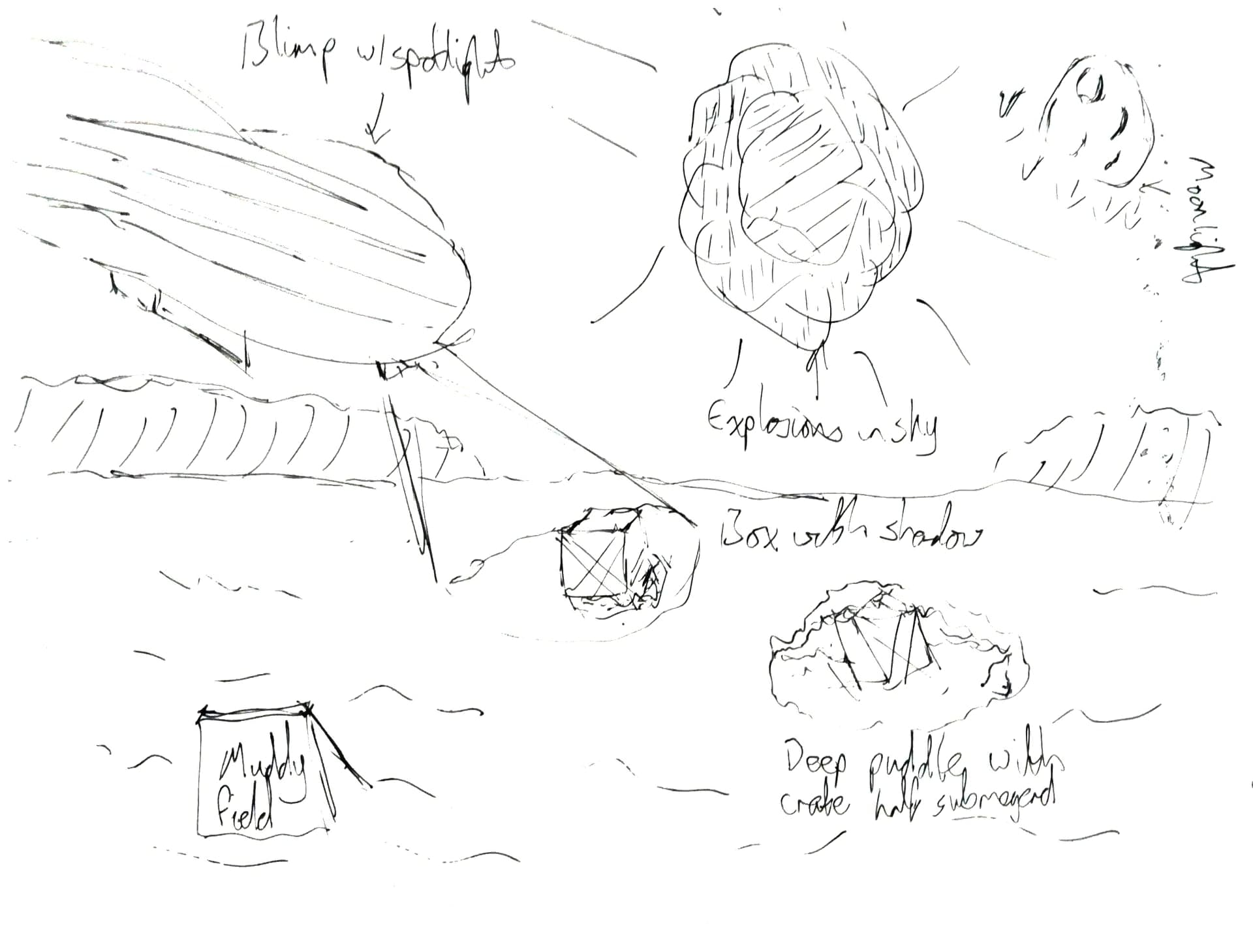

2018

Graphics Programming with Shaders - Report

CMP301

Gabriel Lacey

Scene Overview

# Objects and Techniques

The scene for my coursework application is set in a World War One battlefield, with each object contributing to this theme. The centrepiece of the scene is the terrain object, utilizing the most shader stages and demonstrating the most techniques of all objects in the scene. The terrain starts as a plane, dynamically tessellated with vertex manipulation applied to take on the appearance of a hilly battlefield. This result is then passed through the geometry shader to have blades of grass generated at every tessellated point. Next is the explosion object, starting as a sphere it also has vertex manipulation applied to it, however this time all three channels of the displacement map are used in combination with a time factor resulting in the explosion animating over its lifetime. Each vertex is then passed to the fragment shader and textured to be a different colour based on its progression through the explosion. Zeppelin and biplane models are also used in the scene to help demonstrate the full lighting and shadow capabilities of the scene, one spot light is attached to the zeppelin pointing down towards the terrain, and a point light is created in the explosion class animating along with the explosion mesh. Both these lights have full shadowing capabilities. Once the first pass of the scene is complete, a depth of field post process effect is then applied – focusing the camera’s perspective on whatever it is looking at by blurring out everything else.

# Coursework Brief Response

The scene includes at least one example of all five techniques listed in the coursework specification, with some techniques having more than one implementation. The main challenge in creating this coursework was applying all techniques to work together, mostly all stages in the terrain object.

* Vertex Manipulation
  + A displacement map is used to determine the height of the terrain’s vertices
  + The explosion object uses a multi-channel displacement map to animate over time
  + Both are correctly lit and textured – the explosion mesh, being a light source, has no lighting applied to it but has its output colour at full intensity
* Post processing
  + A depth of field effect is attained by rendering the whole scene to a render texture on its first pass, blurring this texture, and then using both render textures to determine the output texture in the depth of field pass.
* Lighting and Shadows
  + The spot light of the zeppelin and the point light of the explosion are both used to light the scene, with full shadow maps used for both. I chose to implement a point light in this way as it appeared to be the most challenging type of light to implement.
* Tessellation
  + The terrain object is constructed from a predefined number of patches, each patch is individually tessellated based on its distance to the camera. Once tessellation is applied, the terrain then has its normal recalculated to allow for more accurate lighting.
* Geometry shader
  + The tessellated surface of the terrain is then passed to the geometry shader, which reconstructs the terrain faces, and generates three blades of grass for each tessellated point. These blades of grass are then animated to give a swaying effect. All geometry in this stage has correct lighting applied to it and is then textured differently in the fragment shader depending on if the geometry is a blade of grass or section of terrain.

# Controls

* System
  + Tessellation factor controls the maximum tessellation that drops off over distance
  + Wireframe mode shows the base mesh of each object
  + Shadow showcase freezes all objects in an ideal scenario to view shadow interactions
* Zeppelin Controls
  + Move the zeppelin and the light attached about the terrain
* Grass
  + Determine how many blades of grass are generated per GS pass
  + Turn on/off grass rendering
* Explosion
  + Set camera position to explosions position (will need to move outside explosion to view it)
  + Freeze explosion in place at maximum intensity
* Post effect
  + Turn depth of field effect on/off

Algorithms and Data Structures

# Explosion

A separate class was created for explosions so all relevant information for the lighting and mesh itself could be kept in one place, as well as some helper functions to keep the main App1.cpp file tidier.

One of the most important functions in the explosion class is the *GenerateView* function. This is responsible for returning a view matrix based on one of the six possible directions of the point light. Most of the time this is as simple as setting the direction of the light appropriately and then calling the point light’s own *generateViewMatrix* function, however calling that function with a view direction that is either exactly up or down will cause the program to crash. My initial solution to this was to pass in a very small number into either the X or Z parameter of the light direction which fixed the crashing issue, however this also resulted in the light having ‘gaps’ between the vertical direction and three of the four horizontal directions. To negate this the *GenerateView* function instead takes in absolute vertical directions and manually calculates the view matrix instead of using the light’s 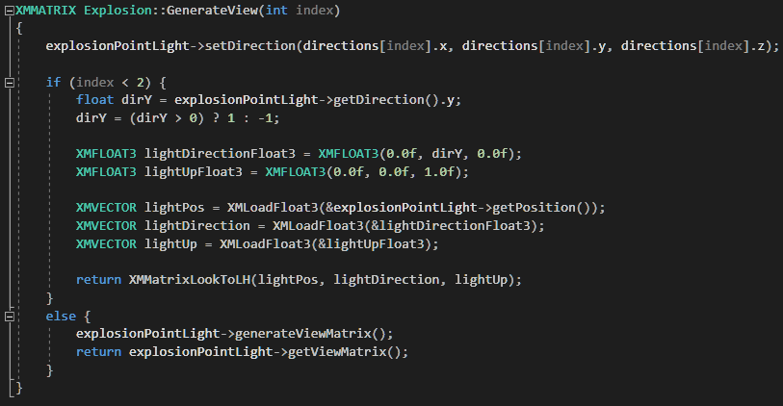inbuilt function, setting the up vector to be the positive Z direction.

Figure 1 - Explosion Generate View Function

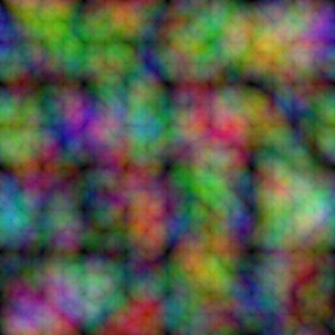The explosion shader itself uses a vertex shader and pixel shader. The vertex shader is passed a multi-channel compose texture and displacement information calculated with sin functions over time for animation. The combination of both results in the individual extrusion of the vertices from their original position. A compose texture is used in place of sending three separate displacement maps giving the advantage of keeping code tidier but more importantly it cuts the amount of data sent to the GPU to a third, without losing any information and therefore reducing one of the main bottlenecks to performance.

Figure 2 - Explosion Compose Texture

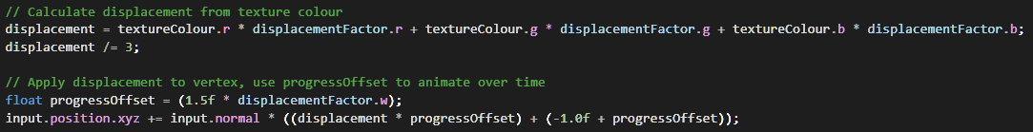

Figure 3 - Vertex Displacement Calculation

These vertices are then passed to the pixel shader, in which their colour is calculated from a colour ramp texture based on their displacement from their original position – the further from the sphere mesh a vertex is, the further along the ramp texture is sampled, starting with a bright almost white explosive colour, then shifting to a darker smoke colour. Vertices may also be clipped at this stage, with the range of clipped vertices expanding over time – this gives the impression of the explosion dissipating, starting with the furthest out vertices and then reaching its way quickly to the centre of the sphere.

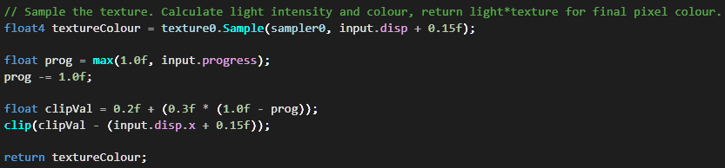

Figure 4 - Pixel Shader Main Function

# Terrain

The terrain shader is by far the largest of all shaders in the program, using every stage of the programmable pipeline covered in this module – though the vertex shader is only used for passing information forward. As mentioned before, the main challenge creating this shader was getting all stages to work together however each of the four main stages also had their own challenges and unique purpose in creating the end terrain object, as detailed below.

Terrain Hull Shader

The main purpose of this stage, as with most hull shaders, is to prepare the patches in the plane for tessellation. Since the level of detail is dynamically controlled, the factor the patch is tessellated by was calculated based on distance. Initially my approach was to simply divide the maximum tessellation factor by the distance calculated, however this resulted in a far too steep decrease in detail, resulting in one patch of highly detailed terrain next to a low detail patch not far from the camera’s view. To solve this, the factor is instead calculated logarithmically, using the current distance as a fraction of the maximum distance of the plane as input. This results in a much more gradual drop off in detail, and at high maximum tessellation values the shift in detail close to the camera is almost unnoticeable.

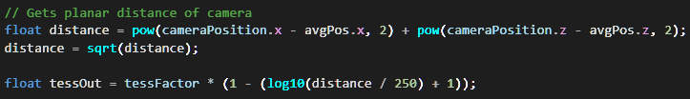

Figure 5 - Tessellation Factor Calculation

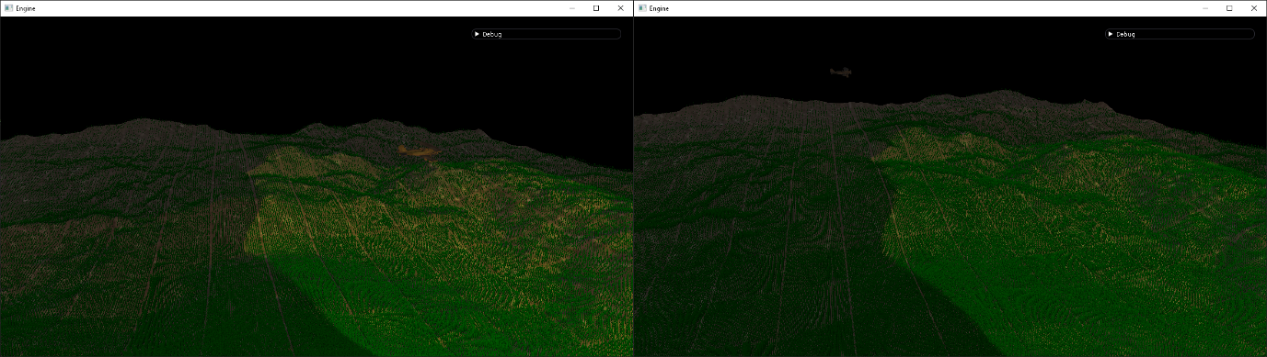

Figure 6 - Division by Distance(L) vs Logarithmic(R)

Terrain Domain Shader

The domain shader has two main purposes; calculating the new vertices’ positions from the original patch positions then modifying these positions based on the displacement map used and recalculating the normals of these vertices to remain correctly lit after the displacement map has been applied. The vertex manipulation is a similar, simpler version of the same method used in the explosion vertex shader – one channel is used instead of three, vertex positions are only moved on one axis, and no animation is involved. The main challenge comes when performing the previously mentioned normal recalculation. My initial approach to this was to calculate face normals in the geometry shader, then apply this normal to each of the vertices of the face. This meant losing a lot of detail when it came to applying lighting to the terrain, and so I instead opted to calculate normals as part of the domain shader based on an estimation of the surrounding vertices.

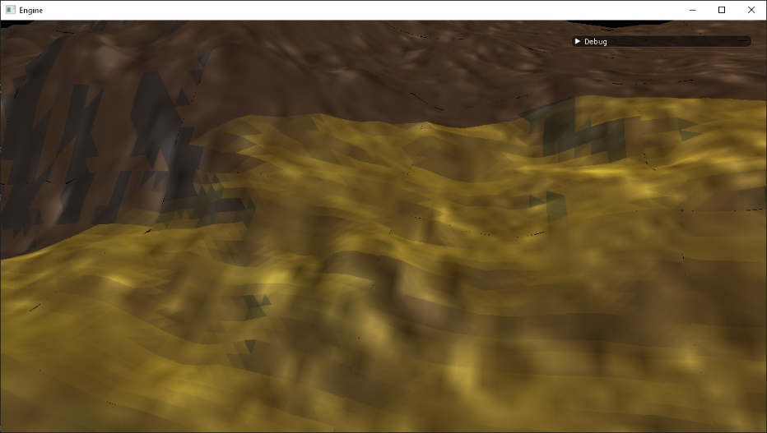

Figure 7 - Per Face Lighting

When implementing this I attempted two different methods; calculating the face normals of the four surrounding faces to the vertex, then combining and averaging these to give the vertex normal required and alternatively calculating the cross product between the two vectors that passed through the terrain vertex from adjacent vertices in the X and Z direction.

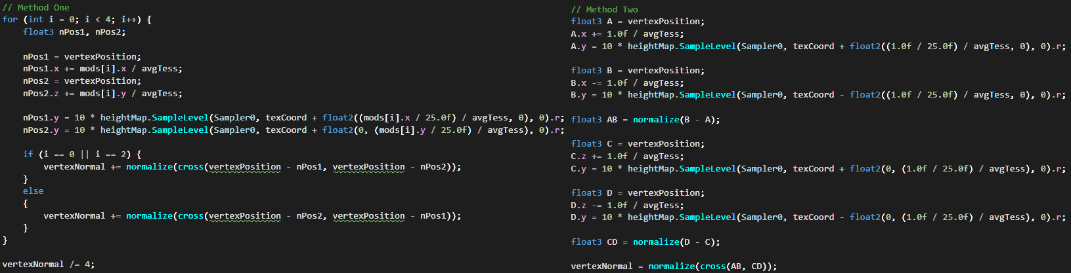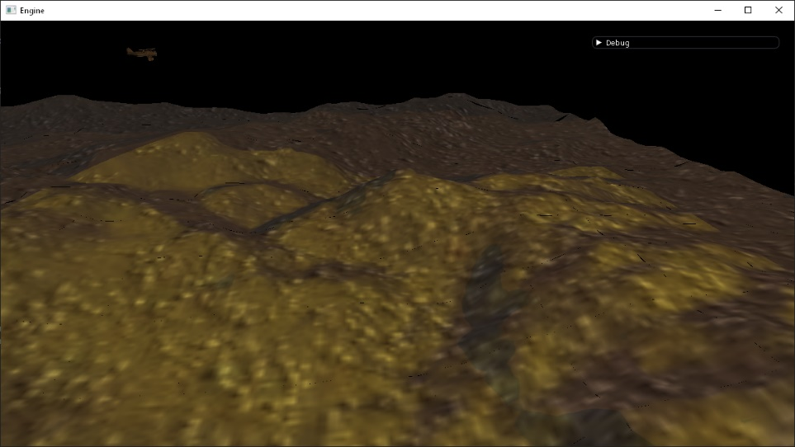Comparing both methods side by side there was no noticeable difference in each result, so I chose to go with the cross product between two vectors method to avoid the branching used in my implementation of calculating adjacent face normal, hopefully improving the GPU performance here by not interrupting the lock-step execution. The result of calculating normals in this way gave much more accurate compared to the previous method, with no visible triangles or faces with lighting applied.

Figure 8 - Adjacent Face Normal (L) vs Cross Product Between Two Vectors (R)

Figure 9 - Per Vertex Lighting, with matched tessellation value of previous example

Terrain Geometry Shader

The first step of the geometry shader is to reconnect the vertices of the terrain and output the resulting triangle to the triangle strip. This is also where the final output parameters of each vertex are set to then be passed to the pixel shader. The texture coordinates and normals are just passed on from being calculated in the domain shader, as well as the position which is first converted to clip space. The vertices position from the perspective of the camera are also calculated here for both the spot light and the point light. The next step is to generate three blades of grass for each tessellated point – each vertex of a blade is calculated using the forward, right, and up vector from the tessellated point’s position, with the forward vector being calculated as the vector between the camera’s position and the point’s position. This has a billboarding effect, so the blades of grass are always within view of the camera. Another approach to achieve this would be to set the rasterizer description to not cull the back faces for the blades of grass. All the same information is then calculated and passed on for each blade of grass as for the terrain. This allows for blades of grass to be partially lit if the bottom vertices are obscured by an object while the top is not, or vice versa.

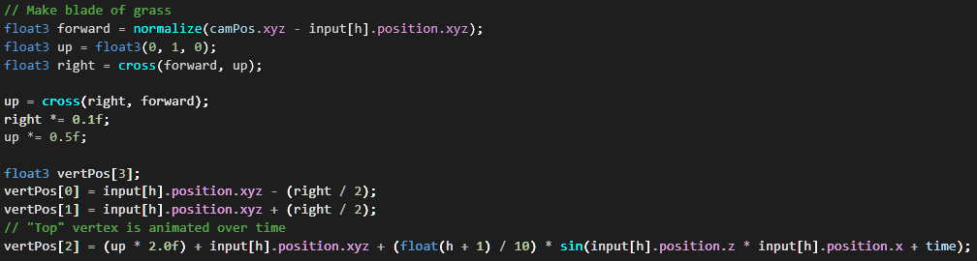

Figure 10 - Grass vertex positions calculation

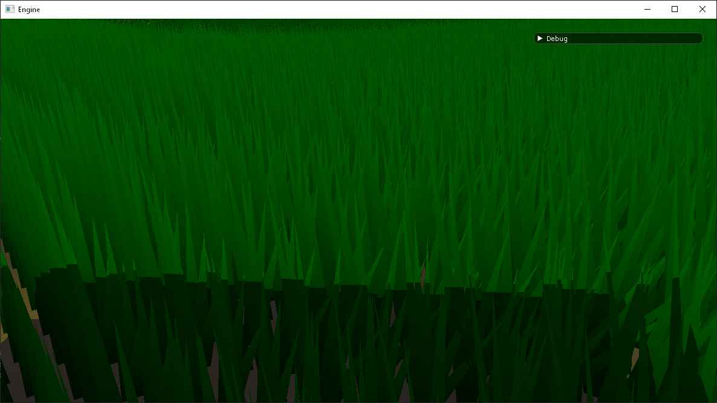

Figure 11 - Partially lit, billboarded grass

Terrain Pixel Shader

Since the pixel shader at this stage is passed two different types of geometry, its first job is to simply decide which texture to sample based on the geometry it is receiving. To inform this decision, I used the last component of the world position output from the geometry shader to indicate if the vertex was created as a section of terrain, or a blade of grass – allowing a different texture for each. After this, the final light colour for the fragment is calculated, for which the light buffer passes in the ambient colour, diffuse colour, direction, and position of each light. All components except the ambient colour is required for every type of light to have full lighting and shadow capabilities however I pass in everything, as well as using a float4 for every component, to ensure correct buffer alignment and to make expanding the amount of lights handled much easier. For the point light of the explosions, six passes are done for each direction of the light to calculate the lighting of a fragment – with a separate shadow map for each pass. This could be optimised to just three passes since a vertex will only ever be in view of three directions of a light at any one time. The spot light only has one pass for its one direction, however, to attain the “cone” effect I wanted for this light, a distance check is done from the centre of the shadow map to the view position of the vertex in place of the usual “bounds” check to make sure the vertex is within view of the full light source.

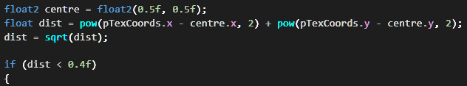

Figure 12 - Spot light distance check

# Depth of Field

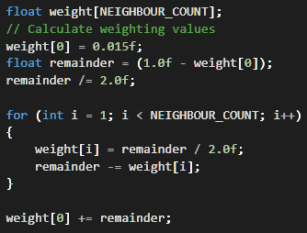Before the depth of field post process effect is applied to the scene, a blurred version of the scene is required as input. For this I expanded on the separable filter gaussian blur example from week eight, firstly by combining both the horizontal and vertical blur pixel shaders into one shader, taking an extra input field to determine which blur is being applied. The second change I made was to automate the weighting value of the neighbouring pixels sampled. To do this, the remainder of subtracting the centre pixel’s weighting from one is halved (to account for both directions from the centre pixel). This remainder is then used when looping through the neighbour weightings, with each neighbour taking half of the remainder as its value which is then subtracted from the remainder itself. Once the loop is complete, the remainder is added onto the centre weighting to ensure the original brightness of the pixel is conserved.

Figure 13 - Blur weighting calculation

Once the both blur passes are finished, the resulting render texture is then passed into the depth of field shader. Here, the colour for the current fragment is sampled from both the unaltered scene view, and the blurred scene view. The difference between the camera’s depth value for the current fragment and the depth at the centre of the camera depth texture is calculated (and divided by a 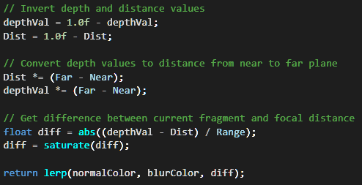given range to specify how far around that plane stays in focus), which is then used to calculate the output colour based on a lerp between the two input textures.

Figure 14 - Depth of Field Pixel Shader

Critical Reflection

Terrain

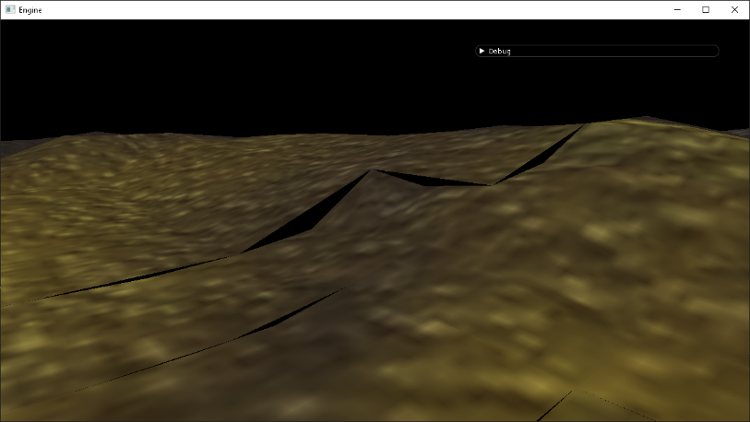Almost every stage of the terrain class has flaws, most of which are introduced when using tessellation. One problem is that of cracks appearing between patches in the terrain when using dynamic tessellation. This is caused by adjacent edges of patches having different levels of subdivision than one another – where one patch has a higher level of detail than the other, causing mismatches in displacement with this differing information. This problem is mostly solved when using high maximum tessellation values, however with more time I would implement a true fix that would work at any level of detail. One possible fix would be to have the edge belonging on the patch further away from the camera inherit the tessellation factor of the edge belonging to the patch closer to the camera. Doing so would also still allow for a decrease in LoD over distance and would get rid of cracks in the terrain since every edge would have the same tessellation factor as its neighbour.

Figure 15 - Cracks in terrain at low max tessellation

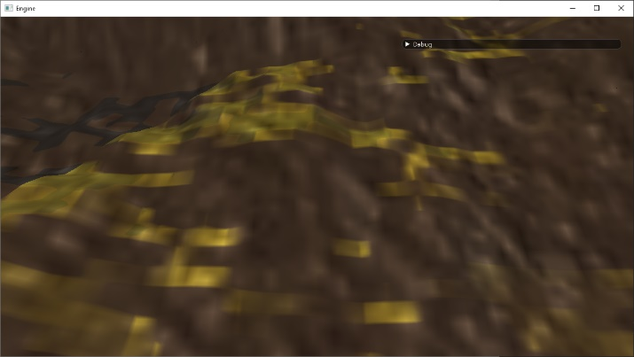Another problem encountered with terrain was the need to generate normals when using a displacement map to dynamically alter the terrain’s height, and the inaccuracies in lighting this can cause. The technique discussed in the previous section to obtain per vertex lighting is a best-guess approach, and while better than using face normals for vertices, this makes it difficult to get perfect. The result are normals which are *mostly* correct, however even at high tessellation values, the transition from lit to shaded areas of terrain is often “patchy”. Doing normal recalculation this way ended up being a temporary fix, and with more time to truly fix this problem I would instead implement the use of normal maps – loading in an accompanying texture to the original heightmap with normal information stored in the RGB colour values, then translating that in code at the same time as applying the vertex displacement. Obtaining this normal map could be done by using third party software such as CrazyBump [1]or NormalMap [2]Online or, in an ideal world, hand drawn by a computer artist. The latter option can result in a higher level of accuracy than the programs mentioned could obtain.

Figure 16 - Patchy lighting

The specific implementation of generating grass linked to tessellated points in the geometry shader also has its own flaws. Firstly, doing so this way means less grass is created at the border between patches, showing distinct squares of grass from patch to patch (as can be seen in figure 6). Additionally, this also has the issue of grass appearing to move as the tessellation value of the terrain changes as the camera moves over it. Finding a solution to both issues is difficult as linking the grass generation so closely to the tessellated points is critical in ensuring the blades of grass are attached to the terrain. One solution could be to perform grass generation as a separate pass, using the origin and dimension of the terrain along with the same height map to manually place grass unlinked from the terrain. If miscalculated though the grass could end up at the wrong height compared to the terrain, possibly resulting in floating grass.

One of the least noticeable flaws in the scene is to do with the use of a constant shadow map bias. This is because the value used was cherry picked after testing to give the most consistent results with the angles the lights in the scene typically appear at, however one value cannot account for every possible angle the explosion point light will appear at since its position is randomly generated, and would further fall apart if a different type of light was used closer to the ground (i.e., a flashlight attached to the camera’s position). The best solution for this would then be to calculate the shadow map bias based on the angle between the light source and the object being rendered.

The final flaw with the terrain class is that it is not rendered in the depth pass, meaning its depth information is not available to any other class that would need it – mainly the shadow map passes, such that terrain does not cast shadows on itself. There are several solutions for this, some not implemented due to other flaws they would introduce and others due to time constraints. The first, most brute-force solution would be to perform the terrain render pass twice, first in the depth pass and then again in the first render pass. The obvious drawback of this is the hit to performance this would cause, somewhat helped by being able to skip lighting calculations in the depth pass however, as I cover later in this report, most of the detriment to performance in the scene comes when generating the grass of the terrain. To avoid this additional problem, grass generation could also be ignored during the render pass however this would mean a loss of detail in shadows that may easily be obtained through other methods. My preferred solution instead would be to output to multiple render targets at the end of the first pass render on terrain – outputting the depth information and render information at once from just one pass. The depth information would then be used in the next frame, merged with the output of all the other depth passes (keeping information on whatever was closest to the depth view point, and discarding what was further). This would mean a very small performance impact when compared with the previous method while still giving high detail, accurate shadows. The main disadvantage of this method would be that the terrain’s depth information would be one frame behind everything else, however this would be far less noticeable when compared to the drawbacks of the previous methods – and even this disadvantage could be solved by using a deferred rendering model instead of forward rendering as it is now, gathering all geometric, normal, and depth information first and then applying lighting to everything at once as a separate pass (also possibly improving performance).

Explosion and Depth of Field

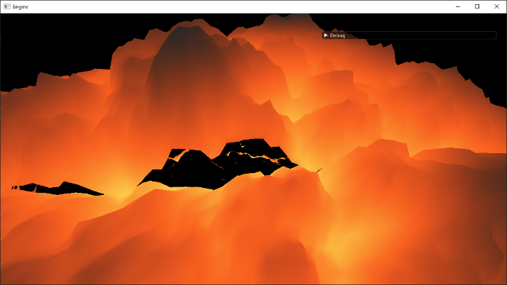The only notable problem with the explosion class is like the first one mentioned in the terrain’s faults – having visible cracks in the mesh when its displacement map is applied. The cause of this is different in the explosion sphere however as it does not make use of tessellation. Instead the problem arises from the displacement texture used not tiling perfectly over the surface of the cube sphere mesh used, making gaps in the mesh where the texture repeats. The fix for this is more straightforward than for the terrain and requires just using a texture that appropriately maps to the mesh used for the explosions, with correct tiling across every face. This solution would have been more difficult with the method I used to create the explosion’s displacement map, generating difference clouds with Gimp, since the random generation means it is almost impossible for the edges to match up.

Figure 17 - Gap in explosion mesh

The primary, and most noticeable, issue with the depth of field effect is that the transition between focus points is immediate based on what the camera is looking at. This makes for a jarring effect when the camera pans over a close object, then immediately over a distant object – making for a harsh change in the blurring of the scene. With more time I would have implemented a gradual shift in the depth of field over time, limiting the amount the focal distance can change either per frame or per second, and having the focus “accelerate” from the old depth to the new depth. The second issue with this post effect is cause by the range of the depth of field being hard coded. This means that an object may appear partially out of focus if they extend beyond the range value used. This could be solved by dynamically changing the range based on the distance between the face the camera is looking at, and the face immediately behind it in the same direction as the camera.

Performance

When running at max settings there is a noticeable performance impact going from about 144+ frames per second to around 30 in my home testing environment (noted below). My initial coursework proposal suggested dynamically down sampling the scene prior to post processing to assist performance, however testing the program with individual components on and off it became clear that the main performance impact comes instead from the high amount of geometry generated on the terrain, mainly the high amount of grass blades created in the geometry shader. The effect can be clearly seen when maximizing tessellation and either toggling grass generation on and off or reducing the number of blades of grass generated with each pass. There are two ways to potentially fix this issue – either by decreasing the maximum allowed tessellation value to 32 (beyond which there is little noticeable difference anyway) or by making the drop off over distance when calculating tessellating harsher, giving even less detail and generating less grass at terrain further from the camera.

References

Testing environment: Debug mode, CPU: Intel Core i5-6600k, GPU: Nvidia Geforce GTX 1070

Zeppelin 3D model and texture: printable_models (2018), Zepplin V2, Available online at:

<https://free3d.com/3d-model/zepplin-v2--65873.html>

Biplane 3D model and texture: 3dregenerator (2013), Biplane, available online at:

<https://free3d.com/3d-model/biplane-58447.html>

Explosion shader tutorial and burn texture: Craeynest, S. (2013), Easy volumetric explosion in Unity3D, available online at:

<https://stevencraeynest.wordpress.com/2013/03/29/easy-volumetric-explosion-in-unity3d/>

Depth of field tutorial: digitalerr0r (2009), XNA Shader Programming – Tutorial 20, Depth of field, Available online at:

<https://digitalerr0r.wordpress.com/2009/05/16/xna-shader-programming-tutorial-20-depth-of-field/>

Terrain displacement map: A3r0 (2006), Heightmap.png, Available online at:

https://en.wikipedia.org/wiki/Heightmap#/media/File:Heightmap.png

Tessellated plane & Potential fix for terrain cracks: Zink, J. (2011) Practical Rendering and Computation with Direct 3D 11 (Chapter 9)

Deferred: Owens, B. (2013), Forward Rendering vs. Deferred Rendering, Available online at:

<https://gamedevelopment.tutsplus.com/articles/forward-rendering-vs-deferred-rendering--gamedev-12342>

1. http://www.crazybump.com/
2. http://cpetry.github.io/NormalMap-Online/